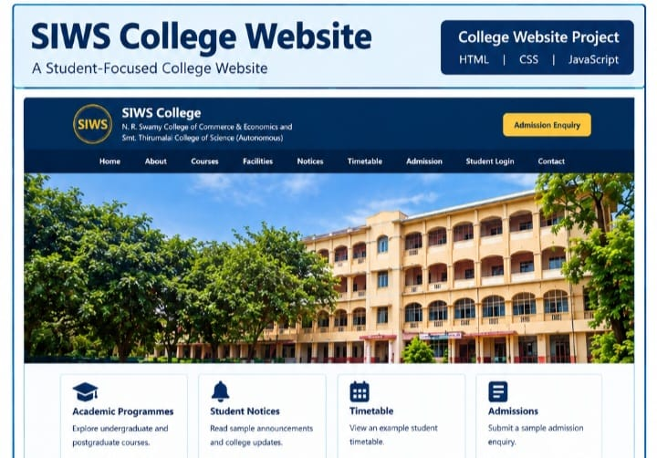
EXPLANATION:-
SIWS College stands for South Indian Welfare Society College, located in Wadala, Mumbai. It provides undergraduate and postgraduate education in various streams, including Science, Commerce, and Information Technology. The college focuses on academic learning, practical knowledge, and students’ overall development.
CODE:-

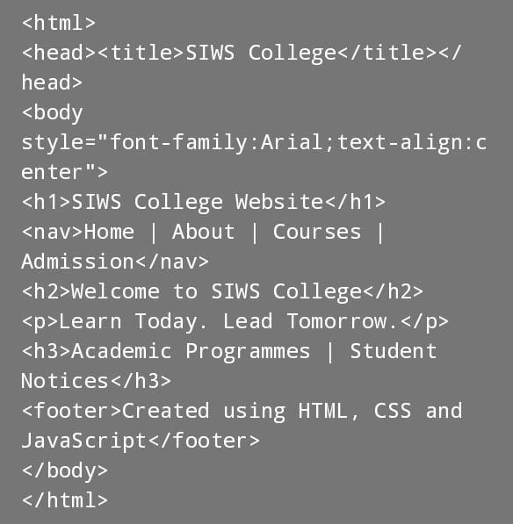
TECHNOLOGIES USED:-
- HTML
- XML
- CSS
- JAVASCRIPT

